POST WWII EUROPE MAP

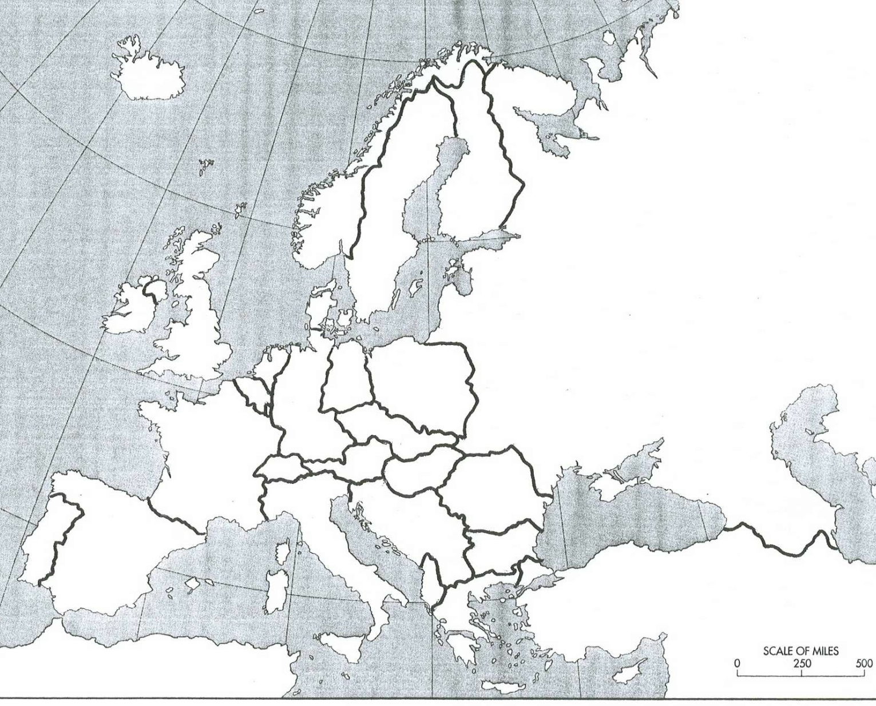

LEGEND

MARSHALL PLAN

N NATO

W WARSAW

Map Directions:

- NEATLY Label the following countries on the map.

  - Albania
  - Austria
  - Belgium-Luxembourg
  - Bulgaria
  - Czechoslovakia
  - Denmark
  - East Germany
  - France
  - Greece
  - Hungary
  - Iceland
  - Ireland
  - Poland
  - Romania
  - Soviet Union
  - Switzerland
  - West Germany
  - Yugoslavia

- Shade in the countries that accepted funding from the Marshall Plan
  - Color the box in the LEGEND with the color your used to represent Marshall Plan funding

- Draw the Iron Curtain across the continent

- Label the countries that joined NATO with an “N”

- Label the countries that joined the Warsaw Pact with a “W”

