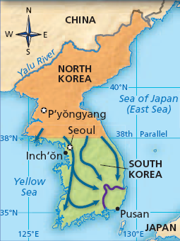
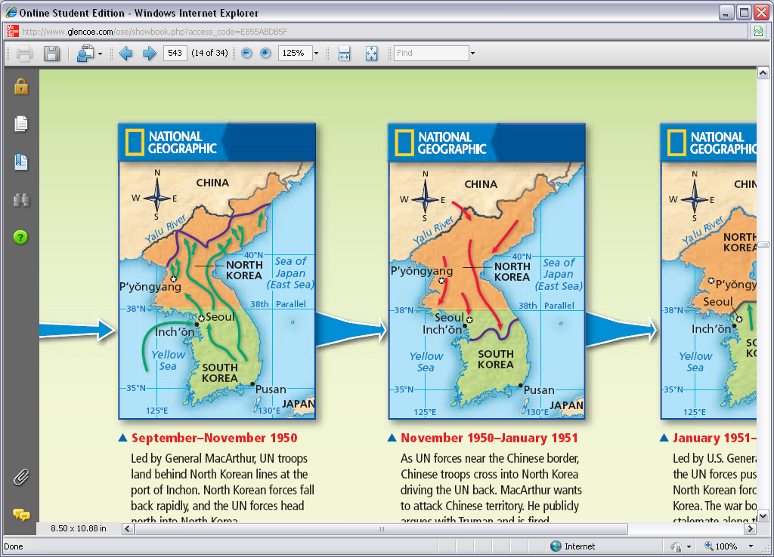
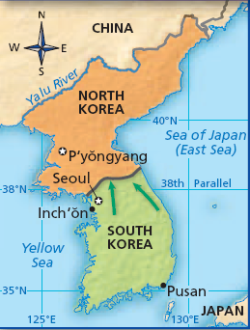
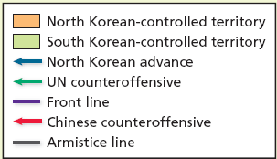
KOREAN WAR “THE FOGOTTEN WAR” 1950 - 1953
At end of WWII:
US and USSR remove the _____________________
US and USSR split Korea at _________________
USSR supports North (Kim Il-Sung)
US supports South (Syngman Rhee)
June 25, 1950
________________________________ Korea - ________
USSR – ________
- South Korean capital of Seoul captured. China - ________
- South Korean forces driven down to ______
US ENTERS with support from ________________ (15 countries)

Gen. MacArthur attempted a daring invasion behind enemy lines.
Amphibious assault on the port of _____________

Invasion was a ______________

__________ was liberated within days of the invasion

North Korean troops retreated back ______________________

MacArthur begs Truman to allow him to cross the 38th parallel.
Truman says _____ but warns ___________________________
MacArthur easily pushes North Korean up near the ____________

Nov 25, 1950 _________________________
US and UN forces are pounded by China and North Korea
Pushed back into South Korea
TERRIBLE WINTER ________

MacArthur argues publically with Truman to _____________________
Truman fires MacArthur “Old soldiers never die, ________________”

US/UN forces push North Korea back to 38th parallel

American policy remained committed to a _____________
War bogs down on the 38th parallel into a 2 year ___________
Truman’s popularity collapses. Does not run for re-election.
___________________________ elected 1952.

Cease fire (__________ ) signed in 1953. NO TREATY EVER SIGNED
Demilitarized Zone (_________) still exists today
4 million total soldiers and civilians killed. ___________ Americans

