The Cold War Name ____________________________________
Political Cartoon Analysis – Introduction Assignment

Directions: Use the political cartoon to help you answer the following questions to the best of your ability.
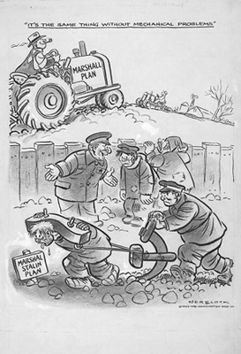

1. Explain the scene in the front of the cartoon.
(Use specific details from the cartoon for support).

2. Explain the scene in the back of the cartoon.
(Use specific details from the cartoon for support).

3. Explain who is saying, “It’s the same thing without mechanical problems,” and the purpose of this statement.

4. Explain what the fence dividing the cartoon symbolizes, as well as its significance.

5. Explain what the Marshall Plan is by using details from this cartoon to support your answer.

