Name _________________________________________ Date ____________ Hour ________

Directions: Study and analyze the following cartoon regarding U.S. Imperialism. Then respond to the following
questions to show your understanding.

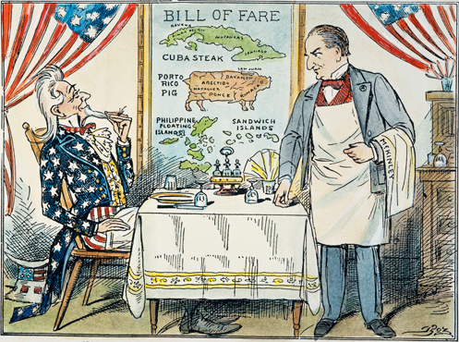

1. Identify the two individuals in the cartoon:

customer -
waiter -

2. What do the items on the menu represent?

3. What is the overall message of this cartoon? Draw on (refer to) the image to support your answer.

Name _________________________________________ Date ____________ Hour ________

Directions: Study and analyze the following cartoon regarding U.S. Imperialism. Then respond to the following
questions to show your understanding.

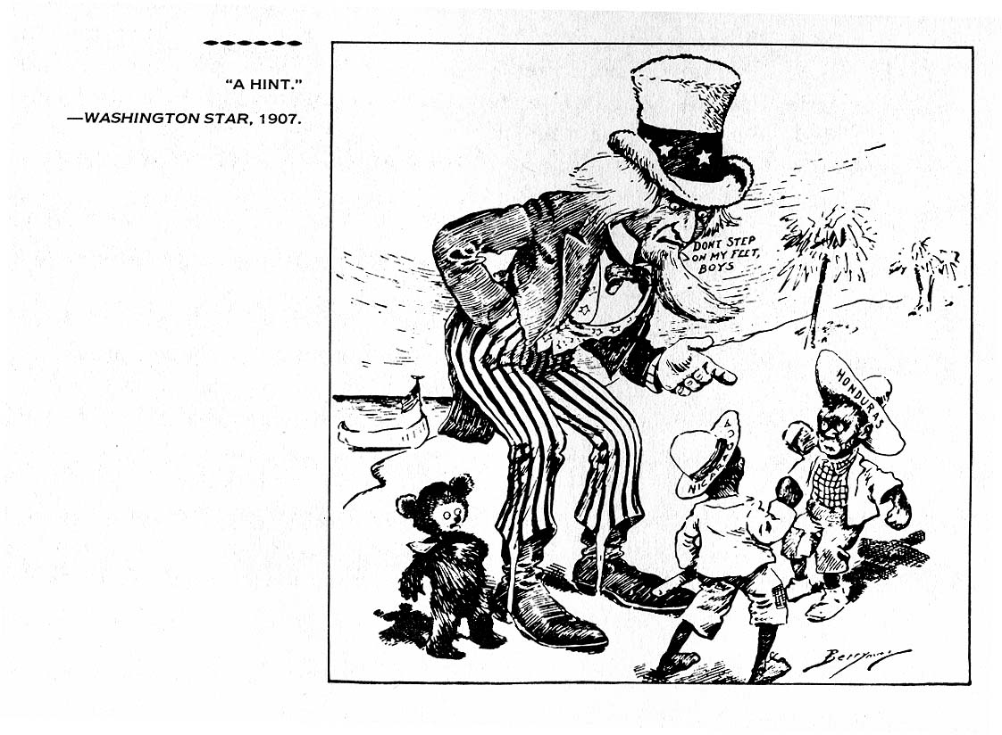
1. Whom or what do the four characters within this cartoon represent?

2. Interpret the meaning of the phrase “Don’t step on my feet, boys.”

3. What is this cartoon implying about the United States? Draw on (refer to) the image to support your answer.

