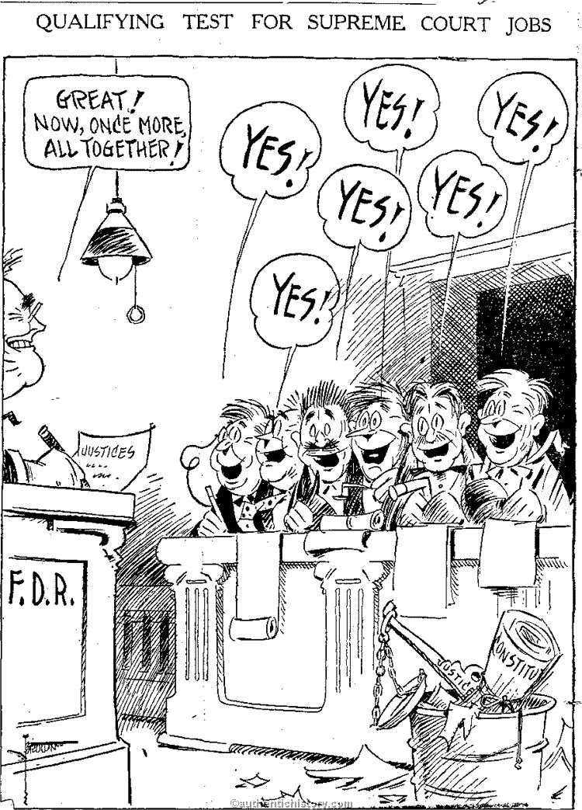

Political Cartoon Analysis:
1. Who is the man on the left? How do you know?

2. Who is the group of men on the right? How do you know?

3. Why are all of the men responding “YES!” ?

4. What is the author’s viewpoint (opinion) of the issue being described?
(Hint: use the items on the bottom, right of the cartoon )

