Ch 11.3
NAME:
HOOVER’S RESPONSE TO THE DEPRESSION

Define RUGGED INDIVIDUALISM -

What was Hoover’s proof for why this policy was best?

HOOVER’S RECOVERY PLAN
What did Hoover believe about giving relief to citizens?
1.
2.
RESULT
DESCRIPTION
PLAN

Industry
Conferences

Public Works

Reconstruction
Finance
Corporation

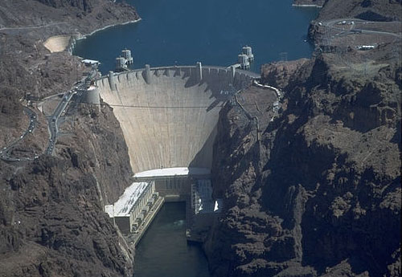
EMERGENCY RELIEF AND CONSTRUCTION ACT
- This act called for

- For the first time in US History

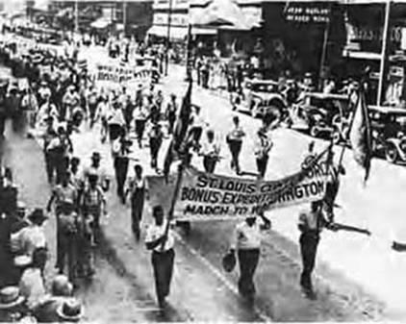
AN ANGRY NATION: Briefly summarize each event in the space provided

Hungry Poor

Farmers

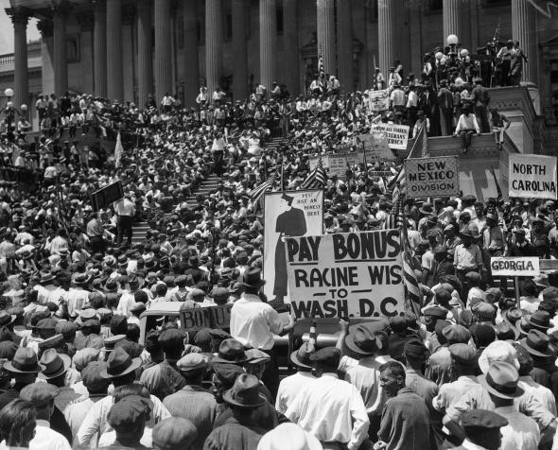

Veterans “Bonus Army”

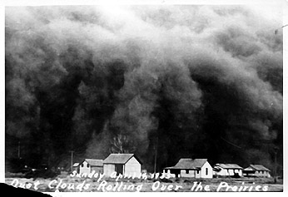
DUST BOWL (Ch 11.2) Read pages 406-407 and 410-411 to identify various causes and effects of the Dust Bowl.
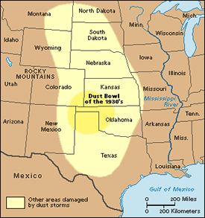
IMPACT:
Dust clouds reached 4 miles high
Dust travelled 3000 miles (to Washington DC and out to sea)
22 storms in 1934 72 storms in 1937
RESULT:

CAUSES:

