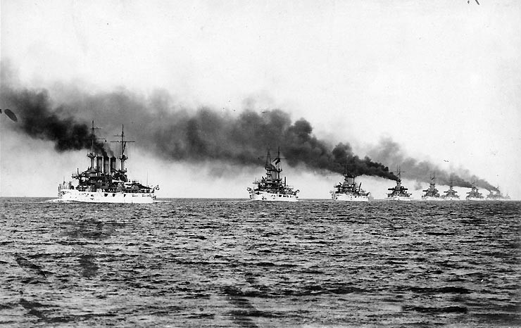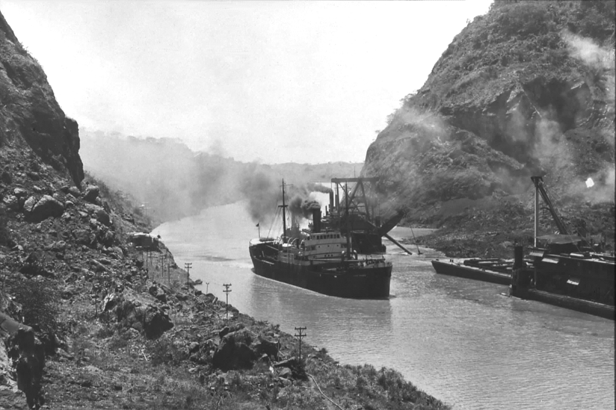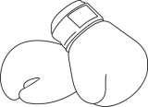

**SPHERE OF INFLUENCE**

**OPEN DOOR POLICY**

**BOXER REBELLION**

**Ch 7.3 NEW AMERICAN DIPLOMACY**

**ROOSEVELT: BIG STICK DIPLOMACY**

**ROOSEVELT COROLLARY**

**PANAMA CANAL**

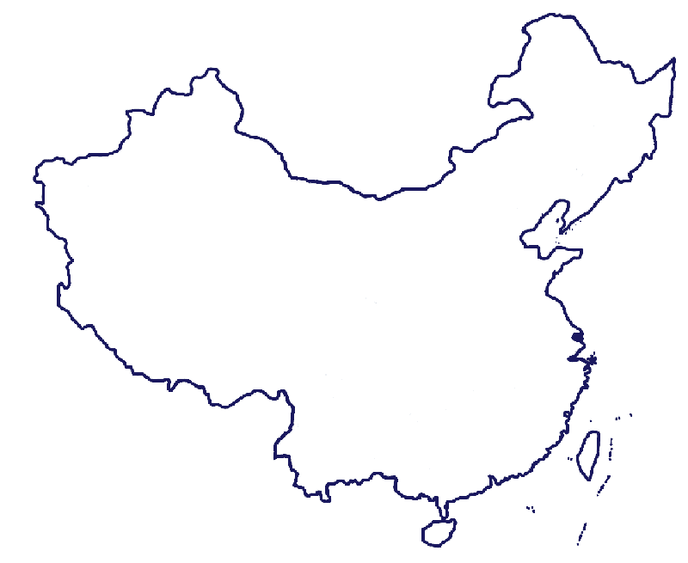

CHINA

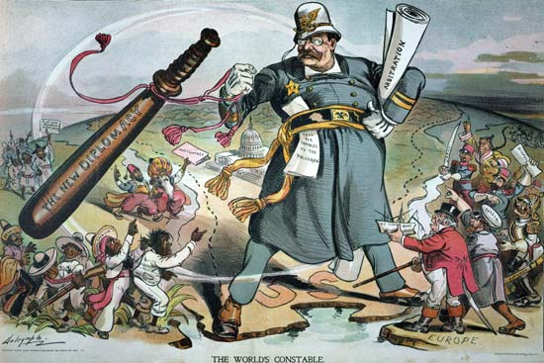

Overall, Wilson’s Mexican policy ____________________

A revolution was unfolding in ______________ and Wilson refused to support the new government, led by

________________________

Wilson opposed ________________________________

And felt the US should promote ___________________

Wilson ordered troops into Mexico, with little success.

In 1917 Wilson withdraws troops over _______________

Guerilla fighters, led by ________________________, raided a New Mexico town killing 16.

American ships were sent to the region and met with

___________________________

**WILSON: MORAL DIPLOMACY**



**TAFT**

**DOLLAR DIPLOMACY**

**TAFT: DOLLAR DIPLOMACY**