Chapter 15.2 Name ________________________
EARLY COLD WAR YEARS

THE LONG TELEGRAM

What was the Long Telegram?

Summarize what George Kennan said in this telegram:

Stalin presented the outside world as hostile to justify his own bloody regime. He told his people that war with the west was inevitable, to increase his power. However, the last thing Stalin wants is war.

Therefore, Kennan suggests a long-term, patient but firm policy of:

COMMUNISM IN THE MIDDLE EAST
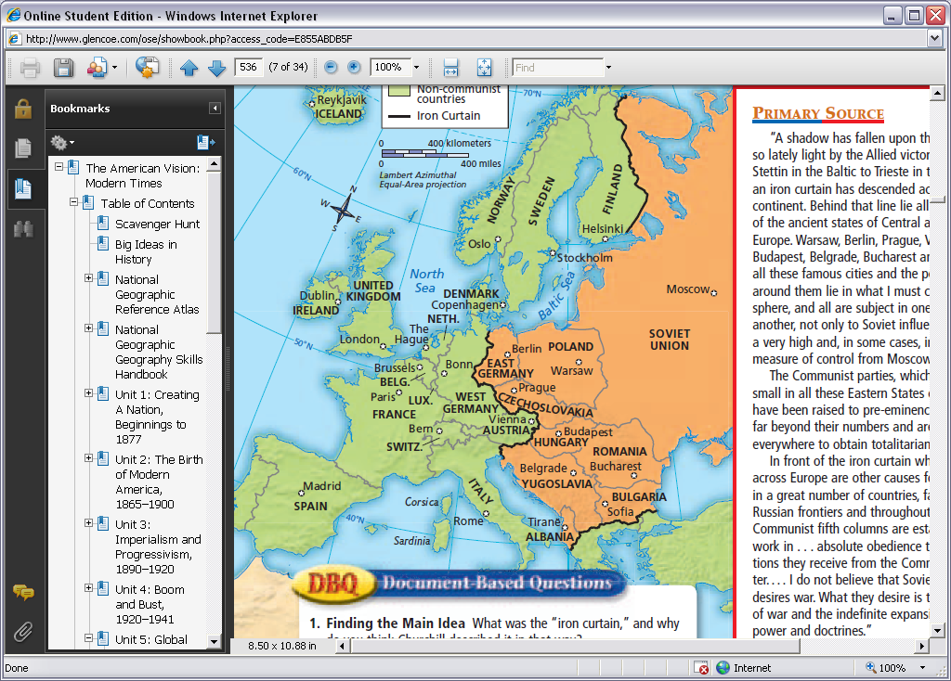
Stalin/Communist Action | Truman/Allied Response | Outcome
 |  | (Hint: It’s the same as Iran!)

1. Iran

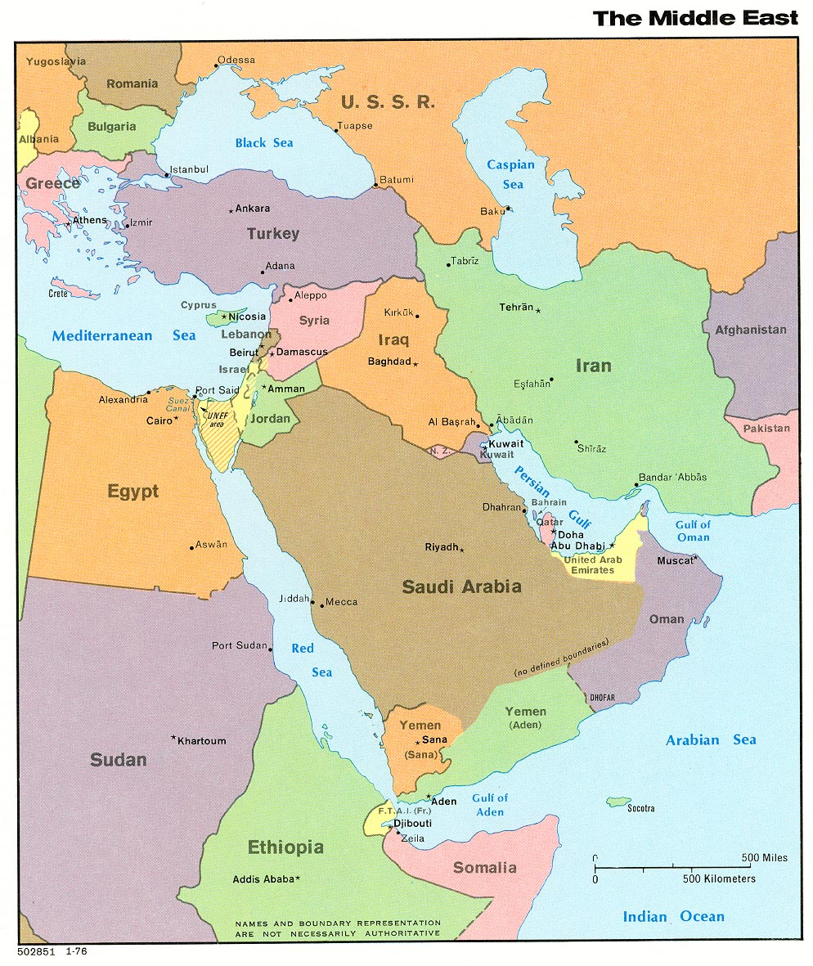

2. Dardanelles
2
3
1

3. Greece

TRUMAN DOCTRINE
Truman asks Congress for $_________ _ to fight against ___________________________________.
The immediate goals are to help _________________ and _________________.
He also pledges the US to __________________________________________ worldwide.
Quick Check: How is this policy different from U.S. policy prior to WWII? (Answer is not in book – use your noggin!)

MARSHALL PLAN

The Marshall Plan was an Economic Recovery Program:
- The US promised aid to _________________, ________________, & _________________.
  - ____________________ accepts aid.
  - ____________________ & ____________________ decline aid.

- Why did Truman offer this plan to everybody, including the Soviets?

- Why did the Soviets refuse the aid?

- In total 17 countries accepted the aide (including West Germany).
- The plan pumped in $13 billion over four years to help countries rebuild. WAS VERY SUCCESFUL.
- US Achieved two key goals
  - Weakened the appeal of _________________ __
  - Opened _________________________________

This further divided the west and east in Europe…..

THE BERLIN AIRLIFT

What key decision did the Allies make to combat Soviet attempts to weaken Germany’s economy?

How did the Soviets retaliate against this by June of 1948?

How did the Allies respond to this? Was it successful?

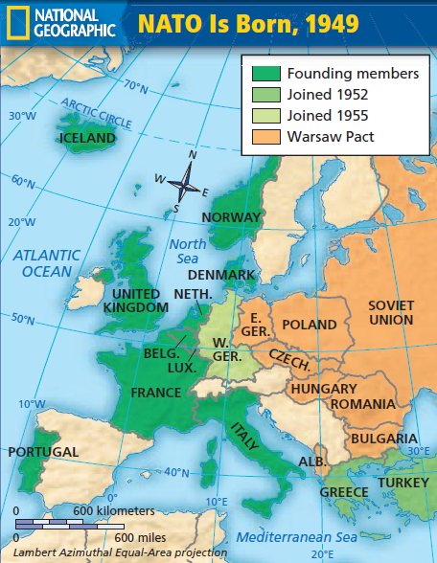
NATO

North Atlantic Treaty Organization - 1949

12 countries from West Europe and the North Atlantic joined and made an agreement to aid any member who was attacked.
Britain France Italy Belgium
Denmark Canada Portugal Norway
Luxemburg Iceland the Netherlands
…AND for the first time in history, the ___________________ committed itself to an alliance in Europe.

________________ joined the alliance six years later

The Soviets reacted to this by forming their own alliance of eastern countries known as ____________________.

